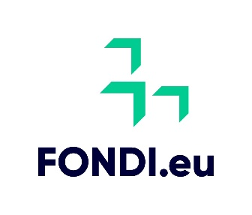

Project Plan Template for Intervention 77.2 Cooperation EIP Operational Groups

**RD COOP EIP Operational Groups**

**Intervention 77.2**

COMMON AGRICULTURAL POLICY – STRATEGIC PLAN

(MALTA) 2023-2027

**Introduction**

***Kindly read the below carefully***

Prospective applicants are to submit **their application online** using the following link: <https://iacs.gov.mt.abacogroup.eu/customerportal/login>

This project plan needs to be submitted as part of the application for Intervention 77.2 RD COOP EIP Operational Groups and uploaded in the section titled: *Supporting Documentation*.

The applicant should read the accompanying measure guidelines before submitting the project plan. The guidelines may be accessed from the Managing Authority’s website: <https://fondi.eu/>

**Contents**

1. Name of the Project and short description 3

2. The EIP Operational Group (OG) 4

3. Scope of the Project 5

4. Description of the expected results 6

5. Dissemination Plan 7

# Name of the Project and short description

**Please include the name of the project:**

Title of project

**Please include short description of the Project:**

(Max 150 words)

**Please tick the main contribution this operation will be focusing on (please only tick one):**

Support for horizontal and vertical cooperation among supply- chain actors for the establishment and development of short-supply chains and local markets, and for promotion activities in a local context relating to the development of short supply chains and local markets.

Support for co-operation among supply chain actors for sustainable provision of biomass for use in food and energy production and industrial processes (waste).

Support for pilot projects, and for the development of new products, practices, processes and technologies

# The EIP Operational Group (OG)

This section should include detailed explanation of the EIP OG group and how this will be functioning.

This section should include whether the group will be newly formed specifically for this project or whether this will be an existing group. In case of the latter, please clearly explain how the group will be focusing on a new idea. In this case differentiation from former or existing activities needs to be justified.

The internal procedures to ensure transparency in the operation and decision making of the group needs to be clearly demonstrated, as well as how conflicts of interest will be avoided.

(Max 500 words)

# Scope of the Project

To include the scope and description of the project and what the project is trying to achieve. This section should describe the reason for undertaking the project, carefully outlining the general and specific project objectives. In other words, it should explain what is intended to be achieved via the project.

(Max 500 words)

# Description of the expected results

This section should include the anticipated outcomes of the project. It should include specific deliverables, measurable milestones, and the overall impact the project is expected to achieve. The results should align with the project's objectives, demonstrating how the proposed solution addresses the identified problem or improves upon the existing systems. This description serves as a clear benchmark for evaluating the project's success.

(Max 500 words)

# Procedures

This section should clearly list the tasks and duties of each member of the OG. This should include all internal procedures to ensure transparency in their operation and decision-making and avoid conflicts of interest. included here.

(Max 500 words)

# Dissemination Plan

This section should include explain how the results of the project will be disseminated. This needs to be on a non-exclusive and non-discriminatory basis using in particular the national and European CAP Networks, as well as local dissemination channels frequented by the end-users wherever possible.

(Max 500 words)

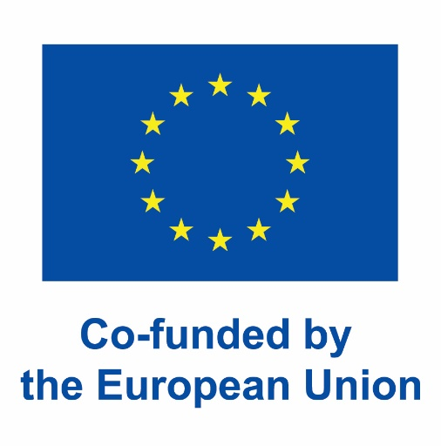**This plan is to be signed by legal representatives of all partners involved in the project (to include Name, Surname, ID Card number and role within the partner organisation)**