Project Proposal

Common Agricultural Policy Strategic Plan 2023 - 2027
Regulation (EU) 2021/2115
Call reference number: CAPSP/2025/I73.5.4

Call | Call 1
Programme | Common Agricultural Policy Strategic Plan 2023-2027
Sub - Measure | I73.5.4 On Farm Productive Investments - Vineyard Renewal and Development
Reference Number (For office use only)

DEADLINE: 28th January 2026 (12:00HRS CET)

⚠ IMPORTANT NOTICE
The Form consists of two parts:
• Administrative information
• Technical description of the project

All data and documents will be treated as confidential, however, information may be shared with other competent authorities when deemed necessary for verification purposes.
Personal data will be handled in accordance with EU Regulation 2018/17252 to ensure compliance with the principles of transparency, proportionality, impartiality and legality.

Applications are to be submitted via email on rdsubmissions.mfi@gov.mt . All submitted project proposals will be acknowledged.

Table of Contents
Administrative Part 4
Project Details 4
Lead Applicant 4
Applicant’s information 4
Details Applicant 4
VAT Status 4
Details of the contact person for the application / project implementation. 5
Sector and Type of Activity 6
Project Costs- Line Items 7
Technical Description 9
Location of Investment 10
List of Parcels 10
Supporting Documentation 11
Supporting documentation required with regards to the applicant. 11
Declarations 12
Annex I – Letter of Intent Template 15
Annex II - Categorisation Matrix 16

Administrative Part

Project Details
Project Title | [Max 15 words] Name of the Project
Project Duration in Months | Enter the number of months required to complete the project.

Lead Applicant
Tick only one option where applicable:
The Applicant |  | Nature of Activity / Business
☐ | Natural Person (Full-Time Farmer) | ☐ | Individual Farmer
☐ | Natural Person (Part-Time Farmer) | ☐ | Partnership
 |  | ☐ | Legal Entity / Limited Company

Applicant’s information

Details Applicant
Name of Applicant | ​​ Clip or tap here to enter text.
ID Card | ​​ Clip or tap here to enter text.
Address – Street, Locality, Postcode | ​​ Clip or tap here to enter text.
Mobile Number | Clip or tap here to enter text.
E-mail Address | Clip or tap here to enter text.
Website (if applicable) | Clip or tap here to enter text.

VAT Status
In the fields below, the Applicant is to include information on the Vat Status of the Applicant Organisation
VAT Number (if applicable) | Insert the VAT number
Can the applicant recover VAT on expenditure incurred? | YES☐ NO ☐

Details of the contact person for the application / project implementation.
Contact Person | ☐ Same as applicant  ☐ OTHER (fill-in below)
Tick, where appropriate, if the OTHER contact person is to be contacted at application stage, at project implementation, or both. | ☐ Application Stage  ☐ Project Implementation

Title (Mr, Ms…) | Mr, Ms
First Name and Surname | Clip or tap here to enter text.
ID Number | Clip or tap here to enter text.
Address – Street, Locality, Postcode | Clip or tap here to enter text.
Mobile Number | Clip or tap here to enter text.
E-mail Address | Clip or tap here to enter text.

Sector and Type of Activity
Tick all relevant sectors related to the intervention:
Sector |  | Type of Activity |  | Type of Production
 |  |  |  | C | O
☐ | Livestock sector | ☐ | Field crops | ☐ | ☐
☐ | Crop Sector | ☐ | Other permanent crops | ☐ | ☐
☐ | Mixed Sector | ☐ | Horticulture | ☐ | ☐
☐ | Non-agricultural sector | ☐ | Wine | ☐ | ☐
 |  | ☐ | Swine | ☐ | ☐
 |  | ☐ | Dairy | ☐ | ☐
 |  | ☐ | Bees | ☐ | ☐
 |  | ☐ | Poultry | ☐ | ☐
 |  | ☐ | Bovine | ☐ | ☐
 |  | ☐ | Sheep | ☐ | ☐
 |  | ☐ | Goats | ☐ | ☐
 |  | ☐ | Rabbits | ☐ | ☐
 |  | ☐ | Other: Click or tap here to enter text. | ☐ | ☐

Project Costs- Line Items
DOUBLE-CLICK ON THE TABLE TO INPUT DETAILS. TOTAL AMOUNTS ARE CALCULATED AUTOMATICALLY. In the table below please provide a complete list of investment of the proposed project to be co-financed by this Intervention. All costs to be provided in Euros and NET of VAT. Only items listed in this section will be considered for application assessment and grant award procedure. Projects co-funded through this Intervention will be assisted with 50% contribution from the European Agricultural Fund for Rural development and Government of Malta funds. Applicants are to refer to the National Eligibility rules for computation of amounts.
To open in Excel, right click on below image, click on ‘Object’ and select ‘Open’.
Note on Indirect Costs - In line with the eligibility rules, projects are entitled to a 7% flat-rate covering overhead expenses. This will be added to calculated on the eligible direct cost of the project.

Technical Description

Proposal
Kindly provide a brief description of the project proposal of what the project will entail.
(Approximately 200 words)
This is a critical section of the application form. Provide a well-focused and coherent description of the central purpose of the proposed investment and alignment to the policy objectives (the proposed policy objectives contributes to economic sustainability, environmental sustainability (climate mitigation and adaptation/ conservation of biodiversity, conservation of soil, resource efficiency and animal welfare), listing all the investments being requested for funding in a clear manner.

Beneficiaries must bring onboard a consultant/viticulturist at application stage who is registered with the Farm Advisory Registration Board (FASB).
Name and Surname of consultant/viticulturist
E-mail address of consultant/viticulturist
Mobile number of consultant/viticulturist

I confirm that I am currently participating in an EAGF/EAFRD AECC3 (Environmental Commitments To Control Weeds In Orchards And Vineyards By Mechanical, Instead Of Chemical Methods) and/or ES2 (IPMP) commitment. I understand that by applying for the On-Farm Productive Investment - Vineyard renewal and development, my parcels currently committed under AECC3
☐NO | ☐YES | ☐N/A

Location of Investment
Where the proposal for investments ONLY includes movable machinery such as tractors, balers etc., this section shall not be completed by applicants.

List of Parcels
Please write down the location/s of your investment.
Parcel Code | Area | Arable Area | Permanent Area

Supporting Documentation

Supporting documentation required with regards to the applicant.
The applicants will be advised further, during the evaluation process, with regards to the submission of any necessary clarifications/documents required.
A soft copy of all documents are to be uploaded.  Supported documents are to be individually presented and adequately titled for ease of reference. | Yes ☐ | No ☐
Tax Compliance Certificate – A certificate issued not earlier than three (3) months from the date of the application, by the Office of the Commissioner for Revenue (CfR) confirming that the Applicant has submitted all returns and has no pending liabilities with CfR; or can otherwise provide official CfR documented evidence that an applicant is honouring an agreement for settling any outstanding amounts. | Yes ☐ | No ☐ | N/A ☐
In the case of letter of Intent from a Winery, the applicant should submit a letter of intent from a licensed winery (Template attached as Annex 1) | Yes ☐ | No ☐ | N/A ☐

Declarations
The Applicant is requested to read through the below statements and confirm that the Applicant will abide with the stipulated declarations. If the information is found to be false or deliberately misleading, any EU Funds awarded may be withdrawn and any funds paid may be recovered from the Applicant organisation completing this form. These obligations shall be considered binding upon signing of the Grant Agreement if the application is approved for co-financing.
 |  | YES | NO
1 | I declare that the entries in this Declaration form, the details in the whole Application Form which is being submitted and any other annexes enclosed are, to the best of my knowledge and belief, correct. | ☐ | ☐
2 | I confirm that access will be allowed to the sites which fall within the scope of this project, to any authorized person for the purpose of carrying out an inspection in order to verify the accuracy of the information in this application and subsequent submissions. | ☐ | ☐
3 | I will follow the set procedures by the Managing Authority with regards to any proposed changes to the project. | ☐ | ☐
4 | I confirm that the proposed project is not directly affected by a reasoned opinion by the Commission in respect of an infringement under Art 258 TFEU that puts at risk the legality and regularity of expenditure or the performance of operations. | ☐ | ☐
5 | I declare:  -to be fully compliant with the eligibility criteria set out in the call;  -to have the financial and operational capacity to carry out the proposed project. | ☐ | ☐
6 | I confirm that I am not aware of any reason why the project may not proceed or be delayed and the commitment can be made within the timescales indicated in the guidelines to which this project relates. I acknowledge that the application will be subject to regular monitoring/auditing/evaluations and undertake to keep records for this purpose in line with instructions received from the MA and ARPA and as described in and any manuals and guidance provided by the MA/ARPA/other stakeholders, as applicable. | ☐ | ☐
7 | I declare that this project is not being supported through other EU and/or National Funding nor have I presented, for the same project, other applications for public aid. I will abide by the principle of good governance and with the spirit of the Public Procurement Regulation on matters related to procurement as applicable. | ☐ | ☐
8 | I declare that the Applicant and/or project partners are not in an exclusion situation in accordance with Art 136(1) and Art 141(1) of 2018/1046 Financial regulation and CPR Art 73 (2)(i). | ☐ | ☐
9 | I declare that I will follow any applicable planning and environmental regulations as may be applicable to the proposed project. | ☐ | ☐
10 | I also declare that by submitting this application, I am hereby giving my consent for the publication of information related to the organisation and the project (including budget) as required by the applicable EU Regulations. | ☐ | ☐
11 | I declare to abide to the durability period obligations in line with the guidance notes. | ☐ | ☐
12 | If the project is approved, I agree to limit the number of change requests as stated in the Grant Agreement. | ☐ | ☐
13 | I agree to allow the Managing Authority to access all data necessary for the latter to be able to carry out its duties in line with applicable Regulations. Personal data transmitted to the Managing Authority and any other stakeholders within the scope of implementation of projects being co-financed by Cohesion Policy is processed, in accordance with the General Data Protection Regulation (EU) 2016/679 and any subsequent amendments. | ☐ | ☐
14 | I confirm that should the applicant benefit from a grant under this Measure, the applicant as beneficiary, must complete the project in accordance with the terms and conditions stipulated in the Grant Agreement. Should the beneficiary fail to do so, the beneficiary will not receive the grant and, if the beneficiary would have already received any payments from the grant, the beneficiary would have to reimburse the funds received and interest charges may be applied. | ☐ | ☐
15 | I declare that the investment is not a simple replacement. | ☐ | ☐
16 | I confirm that information will be provided on the results achieved following implementation of the project and the applicant undertakes to provide this information may be requested, during the durability period of the project. | ☐ | ☐
17 | I am fully aware that I must maintain the project as a going concern during the durability period of the project and I will be subject to ex-post on-the-spot checks. I understand that failure to do this will result in penalties or recoveries being applied. | ☐ | ☐
18 | I am fully aware that the ownership or the location of the project (or part of the project) must remain the same throughout the durability period, unless prior written approval of the Managing Authority is first sought. | ☐ | ☐
19 | I confirm that any further information will be provided as may be required by relevant stakeholders that may undertake audit checks and controls throughout the application and durability period. | ☐ | ☐
20 | I understand that I will not be eligible to apply for other grants or obtain additional funding for the same items if financed through this application. | ☐ | ☐
21 | I confirm that through this application, I am not requesting support to comply with minimum Union Law requirements that I am currently incompliant with and that have been in force for over 24 months from the date of my application, in line with Articles 73 (5) of EU Regulation 2021/2115. | ☐ | ☐
22 | I also understand that if the information included in the Application Form is found to be not factually correct, the application may be rejected, or the project withdrawn. | ☐ | ☐
23 | I understand that email communication on the email address provided to the Managing Authority in this application form may be used for official communication/notification. | ☐ | ☐

Annex I – Letter of Intent Template

[Winery Name]
[Winery Address]

[Date]

[Farmer Name]
[Address]

Subject: Letter of Intent to Purchase Grapes

Dear [Farmer Name],

This is to confirm our intent to purchase grapes from your upcoming vineyard planting located at [Location] with parcel number [XXX XXXX]. This letter serves as a formal indication of our interest and commitment to establishing a long-term partnership to purchase grapes from the mentioned newly planted vineyard.

Based on our discussions and mutual understanding, [Winery Name] intends to purchase grapes from the [grape variety] vines you will be planting in [Month, Year] for the production of [DOK/IĠT] wine according to the local regulations and production protocols falling under the Wine Act Cap 436.

The anticipated first harvest is expected in [Harvest Year], and we look forward to procuring the whole [DOK/IĠT] quota, subject to quality and yield. The purchase price will be determined closer to harvest, based on prevailing market rates and mutual agreement.

Please note that this letter is not a legally binding contract but a statement of our genuine intent to collaborate and support your efforts in producing high-quality grapes for our winemaking operations.

Sincerely,

[Name]
[Title]
[Winery Name]

Annex II - Categorisation Matrix

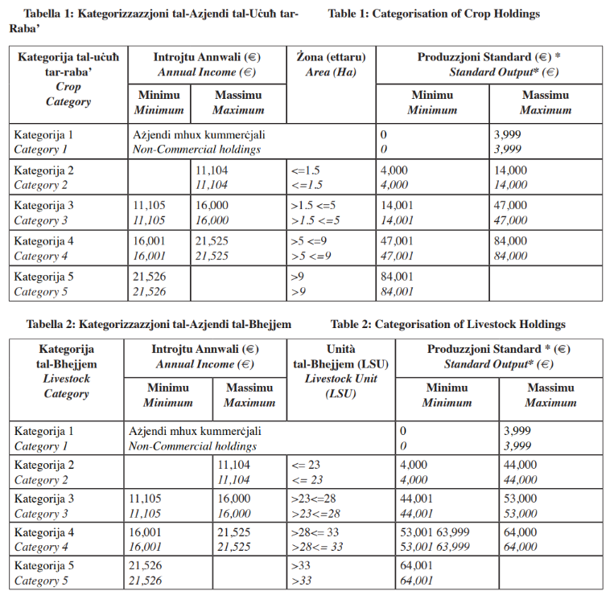

The maximum project duration is 15 months and thus applicants are advised to be realistic in their project plan. The project duration in months will be calculated from the date of the signing of the grant agreement. NOTE: the MA may issue an award with a condition of revised implementation period shorter than the requested period by the applicant.
The mobile number is obligatory prior to issuing a grant agreement.
The email address is obligatory prior to issuing a grant agreement.
C Conventional / O Organic
Note that in case where applicable documentation is still missing at the time of the application, the MA will request the applicant to rectify their situation within a stipulated timeframe.
This can be retrieved from: https://cfr.gov.mt/en/eServices/Pages/IRD-Services-Online-Individual-Taxpayers.aspx
Extract from Government Gazette categorisation benchmarks published on 12th July 2024

