|  |  |  |
| --- | --- | --- |
|  | GREY_EMBLEM | **GOVERNMENT OF MALTA**  MINISTRY FOR THE ECONOMY,  EUROPEAN FUNDS AND LANDS  FUNDS AND PROGRAMMES DIVISION |

**Annex 11 - Funds Recovery Form**

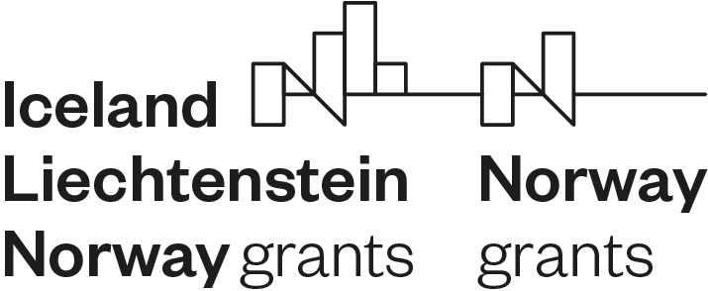

Date:

Name of Project Promoter:

Project Reference Number:

Name of Project Leader:

Reference is made to the project \_\_\_\_\_\_\_\_\_\_\_\_\_\_\_\_\_\_\_\_\_ co-financed by the EEA / Norway Grants 2014-2021, which is being implemented by your organisation.

In this regard, following additional controls carried out by the authorities responsible for payment, verification, certification and/or auditing of the expenditure, it transpired that the amount of **€\_\_\_\_\_\_\_\_\_\_\_\_\_** is irregular and hence should be refunded by your organisation. A breakdown of the transactions making up the irregular amount is attached.

Accordingly, you are requested to take the necessary action through your organisation’s head of accounts for the refund of the irregular amount to the EU Payments Unit within the Office of the Prime Minister. The deadline to transfer funds is the **XX/XX/XXXX** (*should not exceed three calendar months from the note*). Failure to settle the irregularity in a timely manner may lead to suspension of any remaining funds on the operation and/or other operations being implemented by the same beneficiary. Interest on late payment may also be applicable.

Please note that all future payments may be suspended until the above recovery is settled.

|  |  |
| --- | --- |
| \_\_\_\_\_\_\_\_\_\_\_\_\_\_\_\_\_\_\_\_\_\_\_\_\_\_\_\_\_\_\_\_\_\_\_\_\_\_ | \_\_\_\_\_\_\_\_\_\_\_\_\_\_\_\_\_\_\_\_\_\_\_\_\_\_\_\_\_\_\_\_\_\_\_\_\_\_ |
| Head of the National Focal Point | Signature |
| Programme Operator |  |
| (Name and rubber stamp) |  |

|  |
| --- |
| **AUTHORISATION TO TRANSFER/REFUND INELIGIBLE AMOUNT** |

Date:

Head, National Focal Point

Cc EU Payments Unit, OPM

* Attached please find Cheque No. ....... addressed to the Chief Coordinator – EU Payments, Postal Address: 32 House of Catalunya, Triq Marsamxett, Valletta, covering the above-indicated ineligible amount which has to be refunded from our end.
* Attached please find a transfer receipt for the above indicated amount which was transferred to:

Refund (EU Pay) Account IBAN:   MT20MALT011000041000EURCMGS0110

***(Tick where appropriate)***

|  |  |
| --- | --- |
|  |  |

\_\_\_\_\_\_\_\_\_\_\_\_\_\_\_\_\_\_\_\_\_\_\_\_\_\_\_\_\_ \_\_\_\_\_\_\_\_\_\_\_\_\_\_\_\_\_\_\_\_\_\_\_\_\_\_\_\_\_\_\_\_\_\_\_\_

Head of Accounts Signature

(Name & Stamp)

\_\_\_\_\_\_\_\_\_\_\_\_\_\_\_\_\_\_\_\_\_\_\_\_\_\_\_\_\_ \_\_\_\_\_\_\_\_\_\_\_\_\_\_\_\_\_\_\_\_\_\_\_\_\_\_\_\_\_\_\_\_\_\_\_\_

Project Leader (If applicable) Signature

(Name & Stamp)

|  |  |  |
| --- | --- | --- |
| National_Flag_of_Malta_colour_jpeg | Supported by the peoples of Iceland, Liechtenstein and Norway through the EEA and Norway Grants |  |