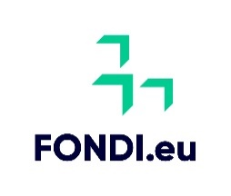

Claim for reimbursement of payments
Select Grant Scheme

- Grant Agreement Number

- Total amount paid in relation to the actions listed in the Claim Form
€

- The amount being claimed
€

- Declarations – Undertaking
  - I confirm and accept that for all intents and purposes I am the legal and authorised person appointed by the Undertaking to act on behalf of the Undertaking for the purpose of this scheme and will be held fully responsible both towards the Schemes and the Undertaking for ascertaining such authority.
  - I hereby recognize and accept that further verifications will be carried out by the competent authorities confirming the veracity of the content of this claim.
  - I hereby confirm and accept that should following verifications carried out, any part of the process is found not to be in conformity with the rules and regulations governing this grant, the entire grant may be refunded on a simple demand.
  - I also fully recognise and accept that any false, inaccurate or incomplete information deliberately provided as part of this claim, will result in the Undertaking being liable to refund the full amount of the grant received with regard to the respective Grant Agreement.
  - I hereby declare, accept and confirm that in the project benefitting this grant, the Undertaking has in place the necessary safeguards to prevent any form of discrimination based on sex, racial or ethnic origin, religion or belief, age, disability or sexual orientation as referred in terms of Chapter 452 and Chapter 456 of the Laws of Malta.
  - I hereby declare that the principles of Community rules and National regulations were followed unconditionally, in the spirit of good governance and transparency.
  - I hereby declare that no funds invested in the operation by the Undertaking are of illicit origin, including products of money laundering or linked to the financing of terrorism.
  - I recognize the obligations to comply with data protection regulations which are in force at all times. I confirm that all relative and related documentation for such eventual verification will be retained.
  - I have read, understood and agree to the Guidance Notes and Guidelines for Implementation issued in relation to this scheme and declare that the information given on this form is true and complete.

☐ I further declare that the Undertaking has not claimed or will not seek to claim the expenditure from any other source of public funding this includes schemes under Cohesion Policy and any other European Union instruments or through any other form of Public Funding including schemes administered through National Funds.

Signature of the Undertaking’s Representative |  | Name and Surname (in block)
Designation within the Undertaking |  | ID No. of Undertaking’s Representative |  | Date

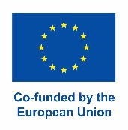
For Measures & Support Division use:
Certified Correct by:
 | Scheme Administrator |  | Signature
Date:

